Testing and Evaluation
Comparative Evaluation of Vision-Based Finger Tracking for Piano Interaction

1. Overview
This document covers the testing and validation of the data collection pipeline and the evaluation of research results. It is organised into three parts:
- Part A (Sections 2–4): Feature validation — testing each pipeline component before data collection began.
- Part B (Section 5): Requirements evaluation — formal completion status of all functional and non-functional requirements.
- Part C (Sections 6–10): Research evaluation — analysis of results across 38 participant sessions.

PART A — Feature Validation
Before data collection began, each pipeline feature was individually tested to verify correct behaviour and eliminate systematic bias in the MPJPE measurements.

2. Environmental and Participant Characterisation

2.1 Fitzpatrick Skin Type Auto-Detection
Skin tone classification was implemented using the ITA (Individual Typology Angle) colorimetric method (Chardon et al., 1991). The system samples CIELab pixel values from the palm convex hull (landmarks 0, 1, 5, 9, 13, 17) across 20 frames to estimate the participant's Fitzpatrick type automatically, removing the need for manual classification and eliminating observer bias.

ITA formula:
ITA = arctan( (L* - 50) / b* ) x (180 / pi)
Where L* is perceptual lightness and b* is the yellow-blue opponent channel. The resulting angle maps to Fitzpatrick types I-VI using the Chardon (1991) thresholds.

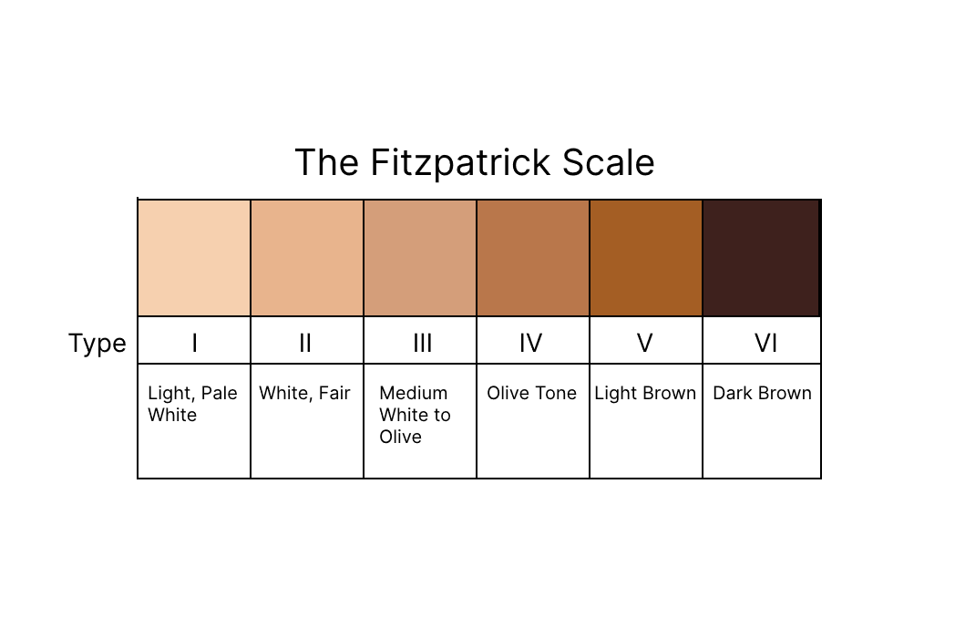
Fig 6.2.1.a: Fitzpatrick Scale reference chart (Fitzpatrick, 1988)

2.2 Ambient Illuminance Classification
Ambient lux was entered manually by the researcher at the start of each session using a mobile phone lux meter app. Manual entry was preferred over automatic camera-based measurement to avoid introducing any measurement-induced variation across sessions.
Lux thresholds (defined in config.py):
Category | Lux range
Dim | < 100 lux
Indoor | 100 – 499 lux
Bright | >= 500 lux

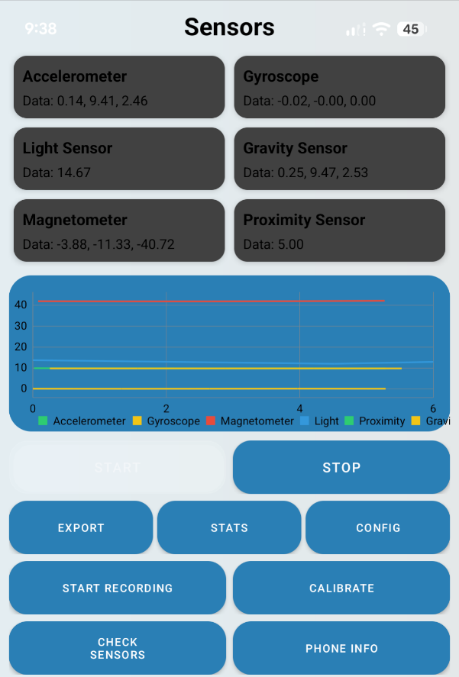
Fig 6.2.2.a: Mobile phone lux meter showing 14.67 lux reading

2.3 Hand Size Classification
Hand size was measured manually before each session using a tape measure from the base of the palm to the tip of the middle finger with the hand spread flat. Values ranged from 7.7 cm to 12.2 cm across all participants. Size was recorded as a continuous variable rather than binned categories to preserve regression analysis precision.

3. MPJPE Calibration and Bias Reduction

3.1 Horizontal-Only MPJPE
The initial 2D MPJPE implementation used full Euclidean distance from fingertip to key centre. This introduced systematic bias because fingers at rest sit higher in the frame than fingers actively pressing keys — a natural anatomical variation that penalised correct detections.
The metric was revised to measure horizontal displacement only:
h_err = | tip_x - key_cx |
This removes the vertical (depth/anatomy) component entirely. Any fingertip Y position within the key height is treated as correct, and only horizontal misalignment contributes to the error score.

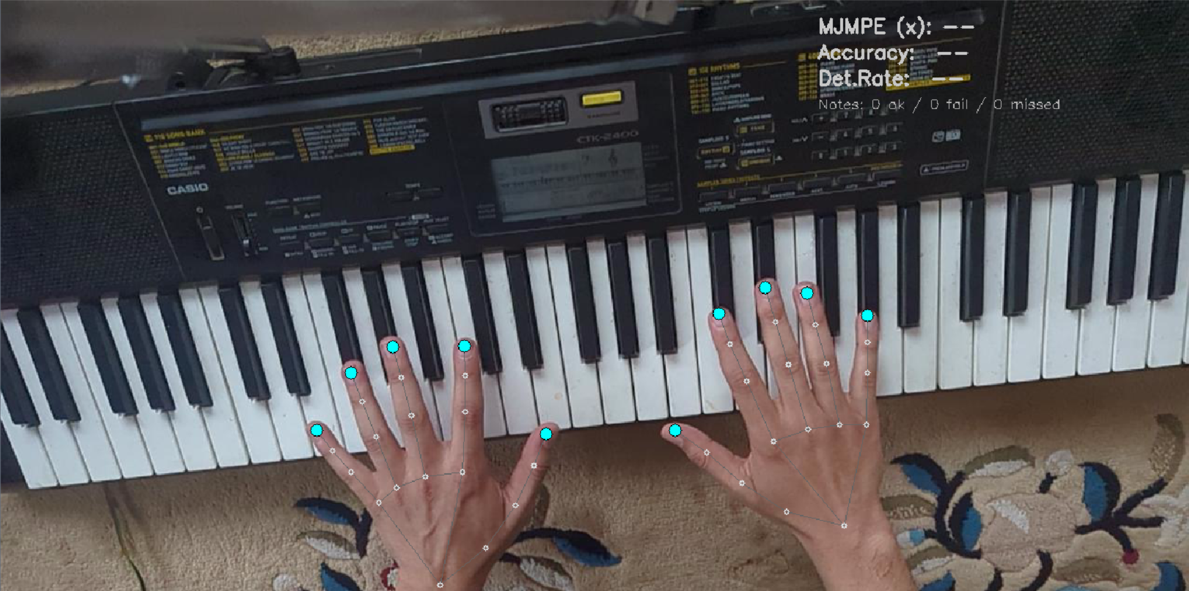
Fig 6.3.1.a: MediaPipe hand landmark preview showing fingertip positions over keys

3.2 Polygon Containment for Finger Detection
A key polygon is a warped quadrilateral matching the physical boundaries of each piano key in the camera view. For each note_on event, a pointPolygonTest determines whether any detected fingertip falls inside the triggered key's polygon. This replaced an earlier centroid-proximity approach that misclassified fingers near adjacent keys.

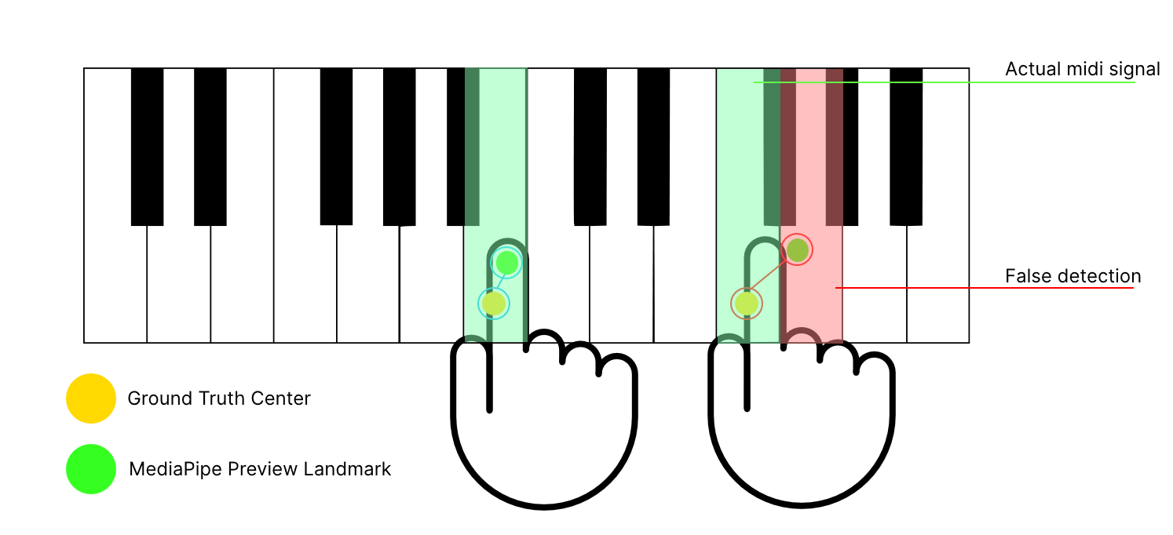
Fig 6.3.2.b: Polygon containment mask — key boundaries drawn on camera frame
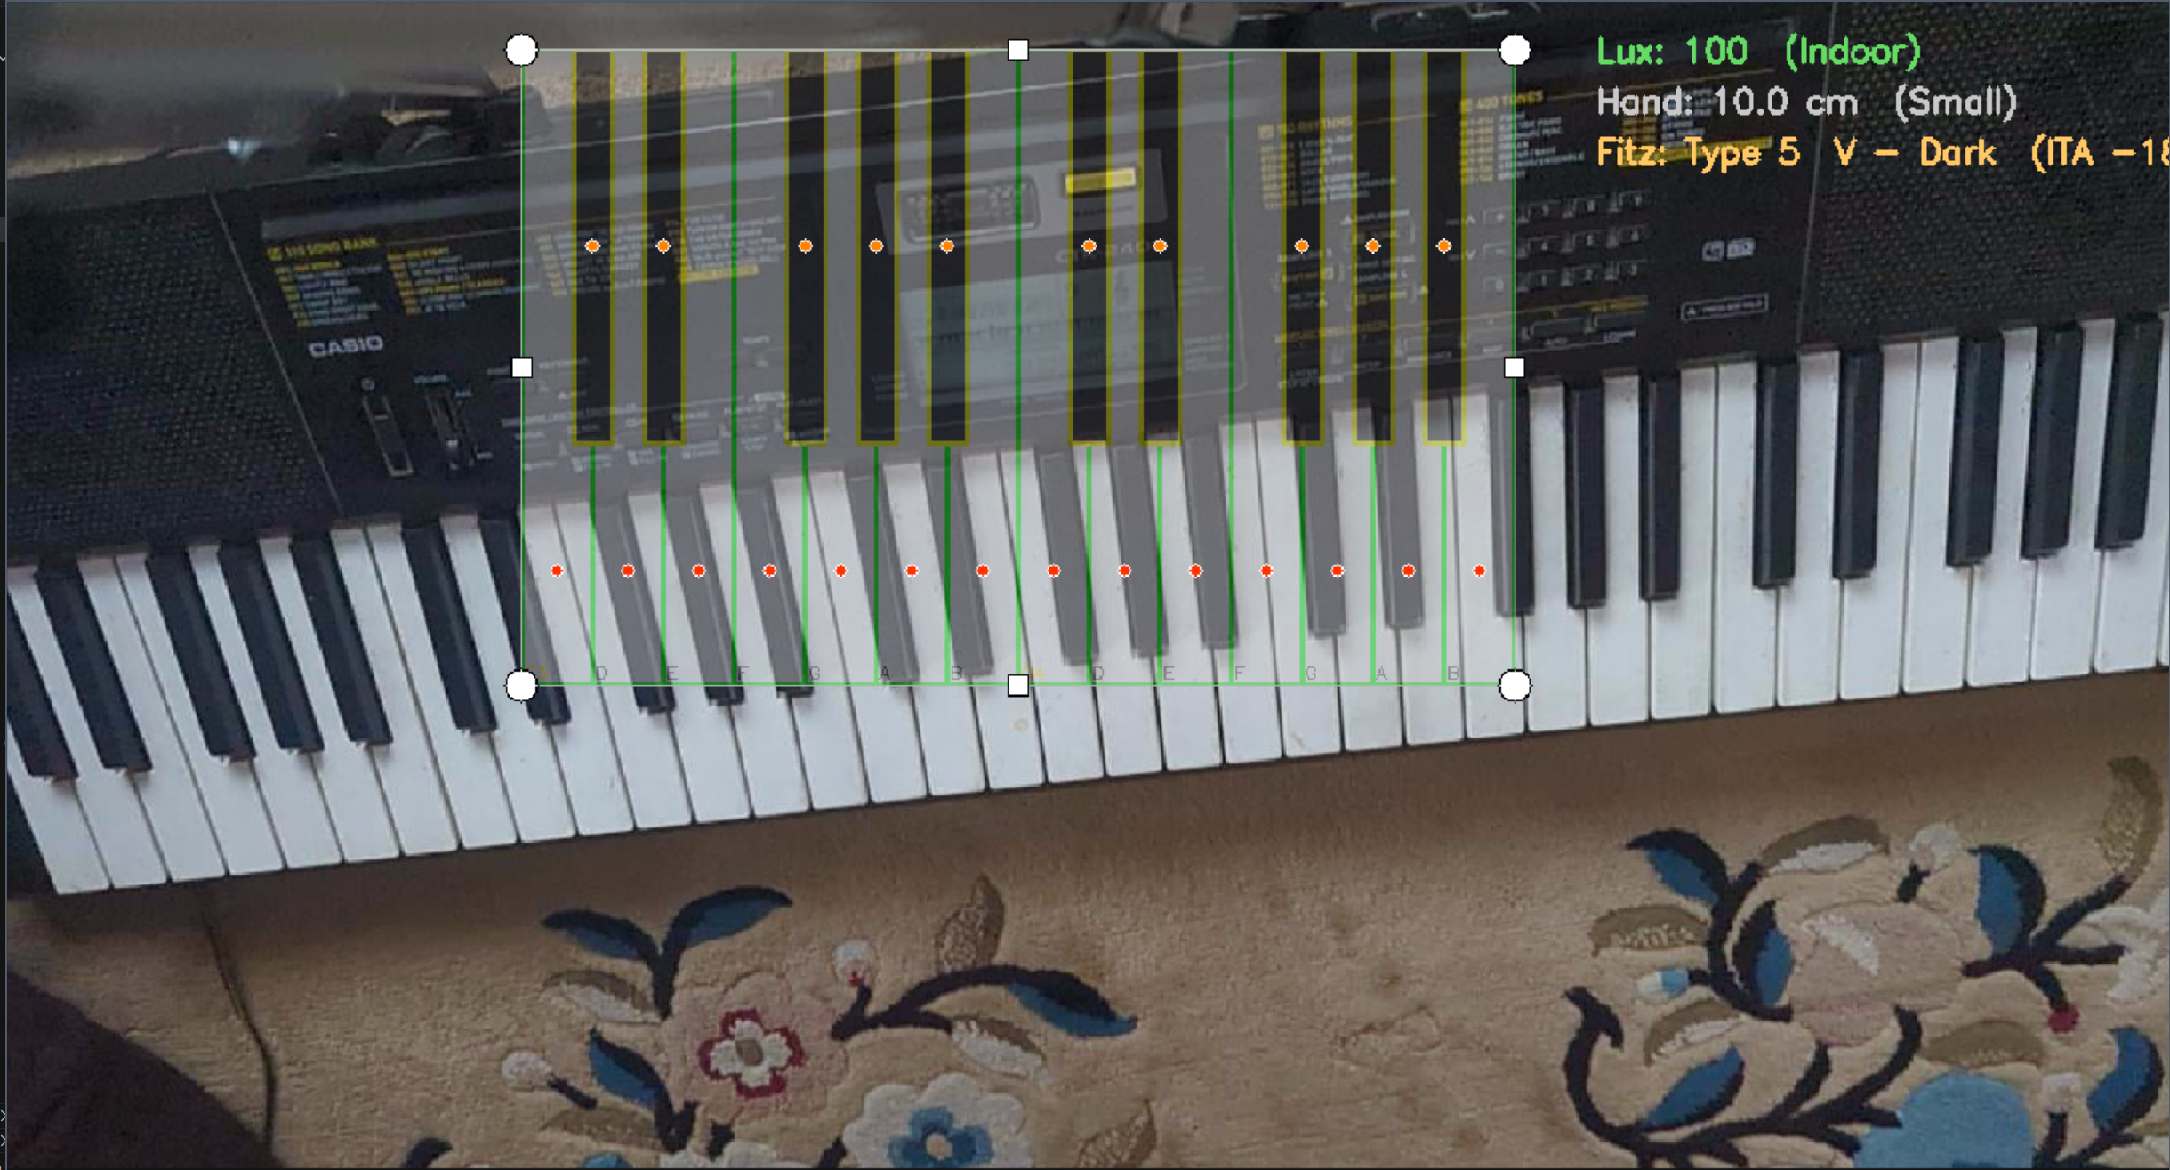
Fig 6.3.2.c: Polygon containment mask preview — fingertips coloured by key match
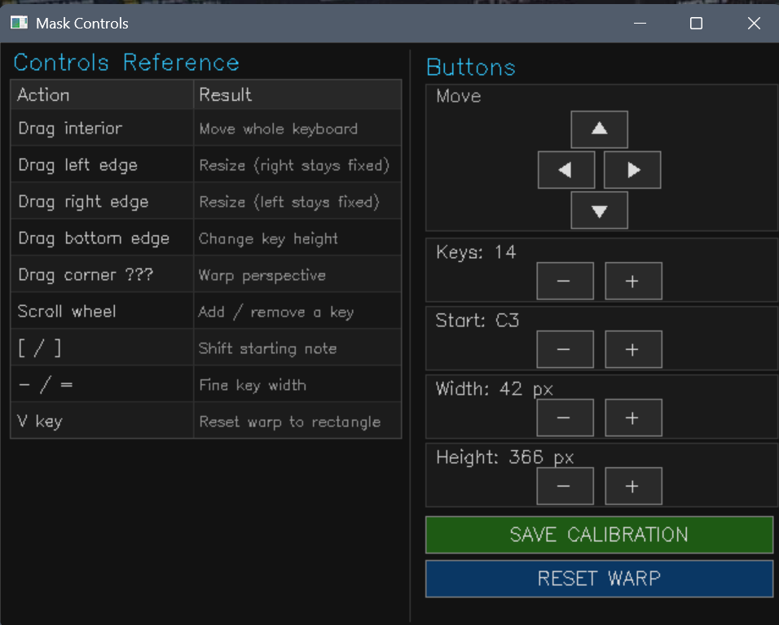
Fig 6.3.2.d: Polygon containment mask control panel

3.3 Perspective Homography Calibration
The overhead tripod position produces an oblique camera angle that distorts the apparent shape of piano keys. A homography transform was applied to warp the key grid from flat 2D space to the camera's projected perspective, ensuring the mask polygons align with the visible key boundaries even at steep viewing angles.
Homography model:
[x', y', w']^T = H [x, y, 1]^T
where H is a 3x3 perspective transform matrix computed from the four corner drag handles in the calibration UI. Warped polygon vertices are recovered by dehomogenisation: x_screen = x'/w', y_screen = y'/w'.

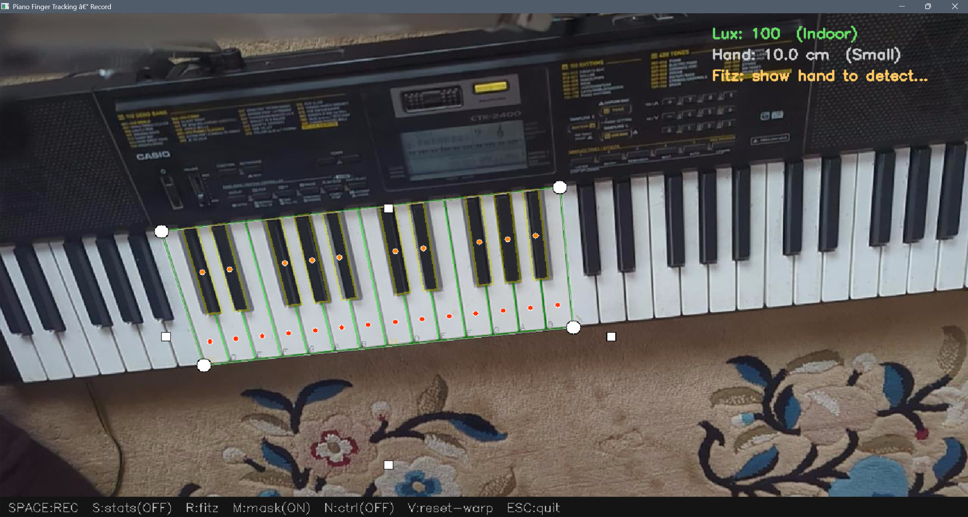
Fig 6.3.3.a: Homography calibration mask — warped overlay aligned to oblique camera view
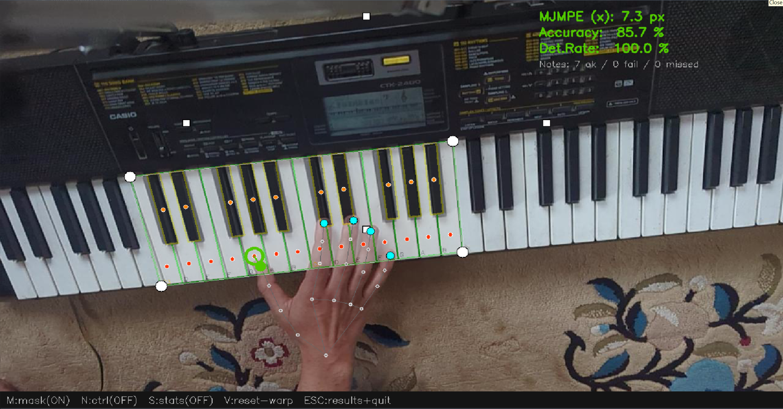
Fig 6.3.3.b: Correct fingertip detection — tip inside warped key polygon
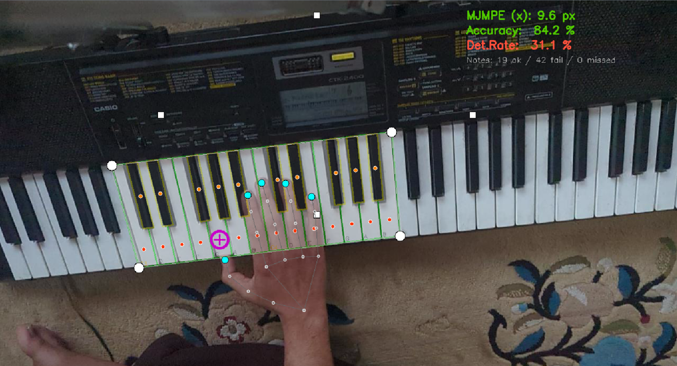
Fig 6.3.3.c: Out-of-polygon false detection — tip outside key boundary
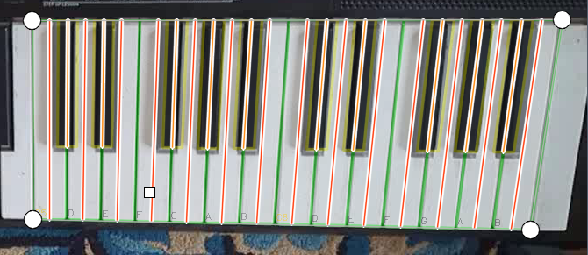
Fig 6.3.3.d: Full-depth vertical line visualisation — shows that any Y within key height is valid

4. Pipeline Feature Tests

4.1 MIDI–Video Temporal Alignment
MIDI and video timestamps were aligned using a shared time origin (rec_t0) set at the moment the SPACE key is pressed to begin recording. The MIDI recorder runs as a background daemon thread, polling the MIDI port every 1 ms using mido's iter_pending() interface. Each MIDI event is timestamped as (time.perf_counter() - rec_t0). The FrameLogger records (frame_index, time.perf_counter() - rec_t0) once per writer.write(frame) call. Analyse.py performs a binary-search lookup to find the video frame nearest in time to each MIDI note_on event.

FINDING Sub-frame temporal precision: at 30 FPS, one frame = 33 ms. The MIDI poll interval of 1 ms gives < 3% temporal quantisation error relative to the frame window.

4.2 System Performance Statistics
FPS, MediaPipe inference latency, and total frame latency were monitored in real time during each session using the StatsCollector class. A warmup period (configurable in config.py) was excluded from rolling averages to allow the camera and model to stabilise.

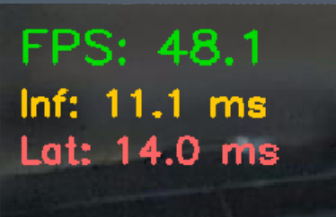
Fig 6.5.a: live_preview.py performance stats overlay — FPS, inference, and latency

4.3 Live MPJPE Test Results
live_preview.py displays a real-time results panel after each test session. The panel shows per-hand and per-finger MPJPE, accuracy percentage, and detection rate.


Fig 6.5.b: live_preview.py end-of-session results panel — left hand breakdown
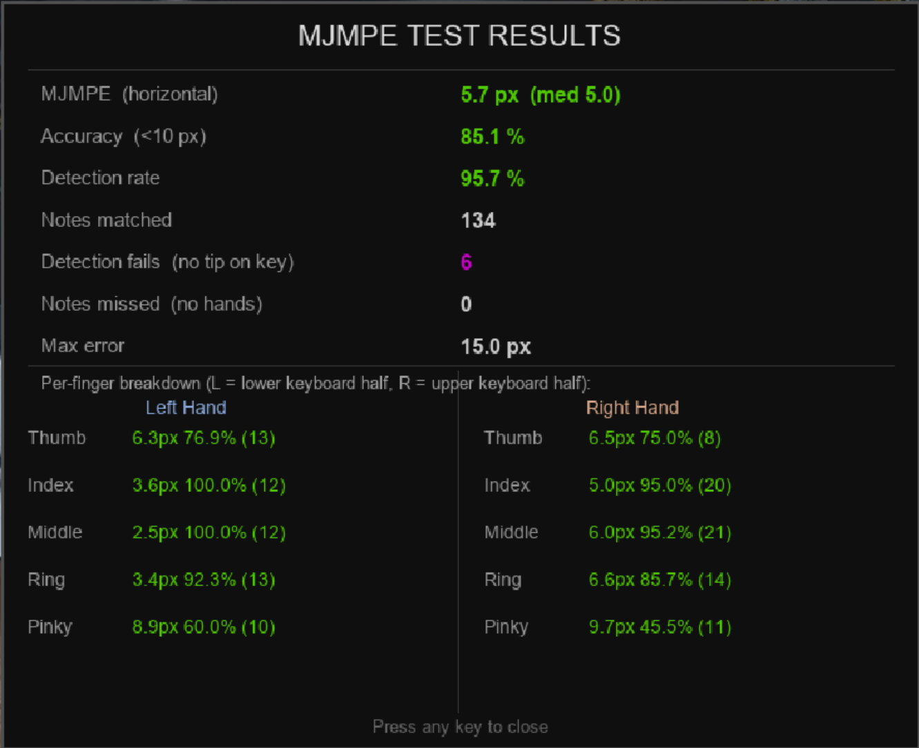
Fig 6.5.b: live_preview.py end-of-session results panel — right hand breakdown

4.4 Raw Data Storage Structure
Each session writes to a dedicated data/raw/p###/ folder containing the raw video, frame timestamp CSV, MIDI JSONL, standard MIDI file, and a session metadata JSON with all demographic and environmental variables.

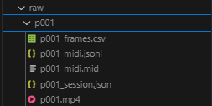
Fig 6.3.3.a: Raw data folder structure for one participant session

PART B — Requirements Evaluation

5. Requirements Completion

5.1 Functional Requirements
# | Requirement | MoSCoW | Status
FR-01 | Finger landmark tracking via vision models | Must | Completed
FR-02 | MIDI ground truth capture | Must | Completed
FR-03 | MIDI-video temporal synchronisation | Must | Completed
FR-04 | Multiple open-source model support | Must | Partially completed (MoveNet excluded)
FR-05 | Camera-to-keyboard spatial calibration | Must | Completed (homography polygon mask)
FR-06 | Data logging system | Must | Completed (CSV, JSONL, JSON, MP4)
FR-07 | Keypress event analysis | Must | Completed (polygon containment)
FR-08 | Quantitative performance metrics | Must | Completed (MPJPE, detection rate, FPS)
FR-09 | Controlled variation of conditions | Must | Completed (Fitzpatrick, lux, hand size)
FR-10 | Statistical model comparison | Must | Completed (descriptive stats + charts)
FR-11 | Model selection justification | Must | Completed (report sections 3 and 8)
FR-12 | Reproducible protocol documentation | Should | Completed
FR-13 | Additional model evaluation | Could | Not completed (MoveNet format mismatch)
FR-14 | Real-time visualisation overlay | Should | Completed (live_preview.py)
FR-15 | Automatic occlusion annotation | Could | Not completed (descoped)
FR-16 | 3D hand pose estimation | Won't | Correctly excluded
FR-17 | Mobile / embedded deployment | Won't | Correctly excluded
FR-18 | Multi-camera tracking | Won't | Correctly excluded
FR-19 | Real-time audio feedback | Won't | Correctly excluded

5.2 Non-Functional Requirements
# | Requirement | MoSCoW | Status
NFR-01 | Research-focused prototype | Must | Completed
NFR-02 | Fair and controlled comparison conditions | Must | Completed
NFR-03 | Python + open-source libraries only | Must | Completed
NFR-04 | Ethical compliance and participant protection | Must | Completed (ethics stages 1 and 2)
NFR-05 | Real-time performance >= 15-20 FPS | Should | Completed (30 FPS sustained)
NFR-06 | Code quality and reproducibility | Should | Completed
NFR-07 | Basic robustness and error handling | Could | Completed

RESULT All 11 Must requirements are completed. FR-04 is partially completed — MediaPipe and OpenPose are both integrated; MoveNet was excluded because its output format is incompatible with the 21-keypoint landmark schema used throughout the pipeline.

5.3 Prototype Benchmark Application
A prototype studio-style GUI was developed to allow researchers to switch between pipeline scripts using on-screen buttons rather than terminal commands. This was evaluated as a potential future tool to improve usability during data collection sessions.

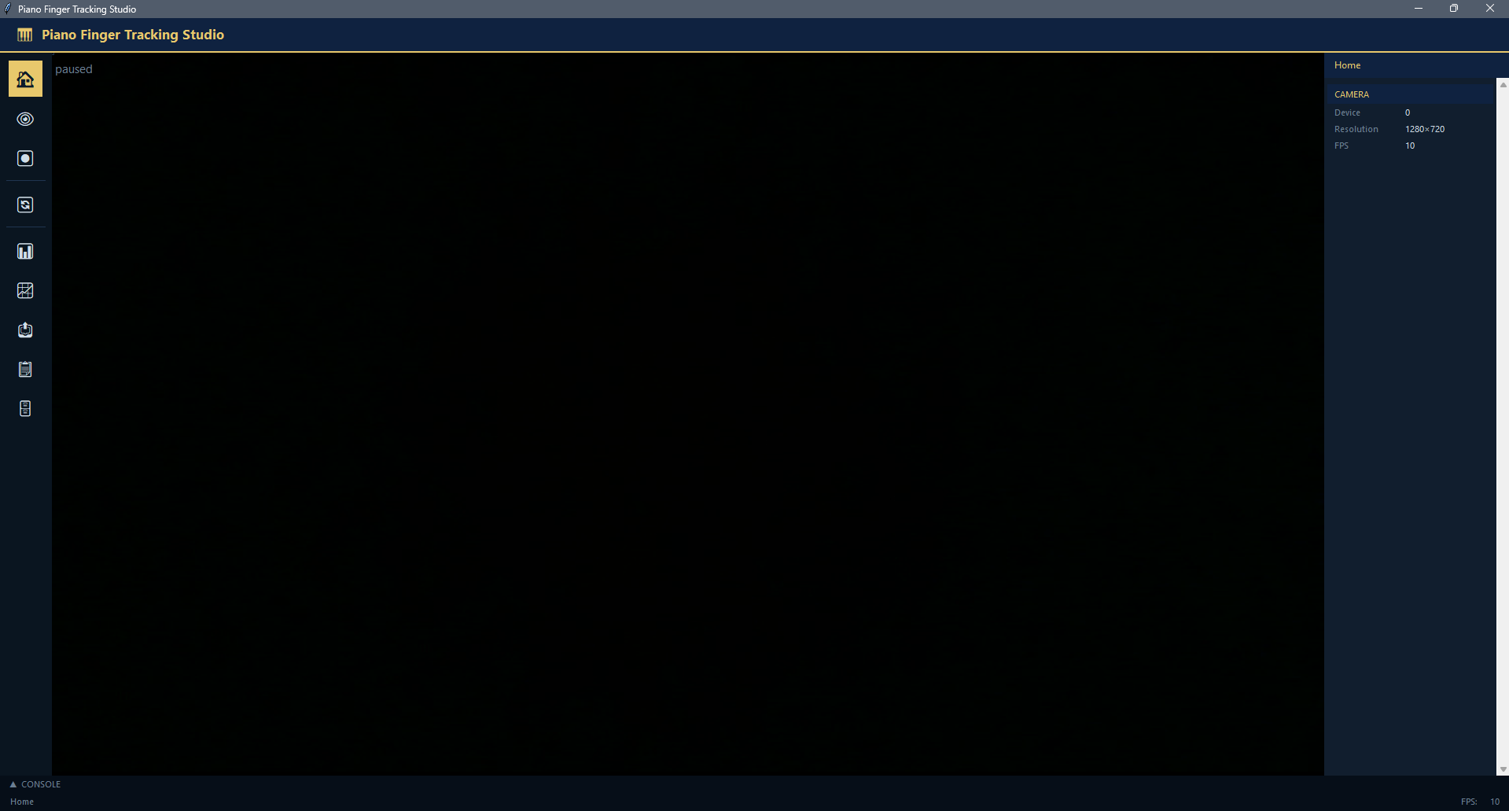
Fig 7.3.a: Prototype benchmark application UI design

PART C — Research Evaluation
38 participant sessions were completed. 89,560 video frames, 9,557 MIDI events, and 4,777 note-on events were processed. Participants covered Fitzpatrick types II–V, with the majority in types III and IV. All sessions were conducted indoors under Dim or Indoor lighting.

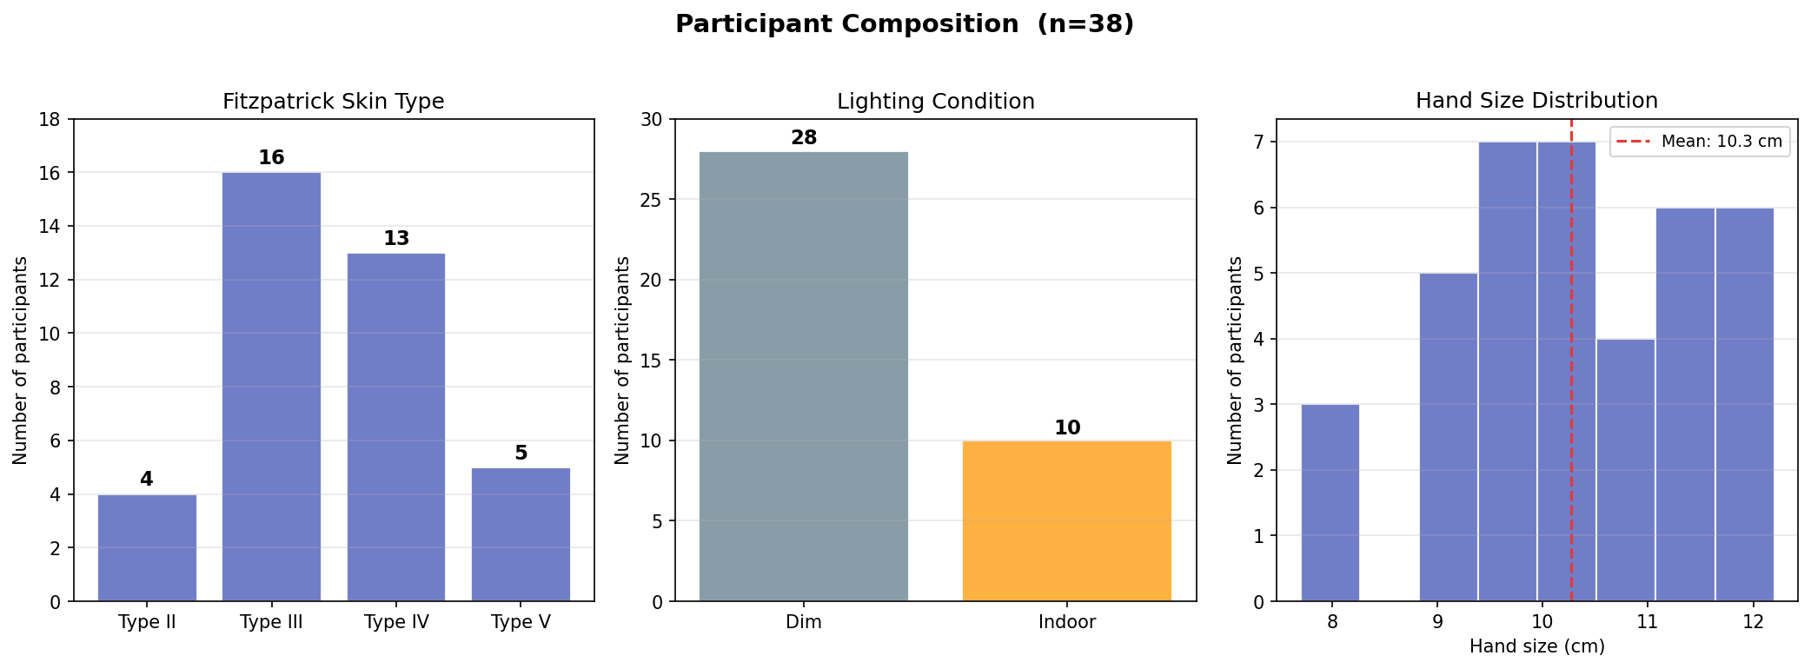
Fig 8.a: Dataset diversity charts — Fitzpatrick type, lux, and hand size distributions

6. Model Detection Rate

6.1 Overall Detection Rate
Detection rate is the proportion of note_on events where at least one fingertip landmark was found inside the triggered key's polygon.
Outcome | MediaPipe (n) | MediaPipe (%) | OpenPose (n) | OpenPose (%)
Matched | 3,017 | 63.3 | 388 | 8.1
Detection fail | 1,370 | 28.7 | 1,039 | 21.8
Missed | 390 | 8.2 | 3,350 | 70.3
Total note-on | 4,777 | 100 | 4,777 | 100

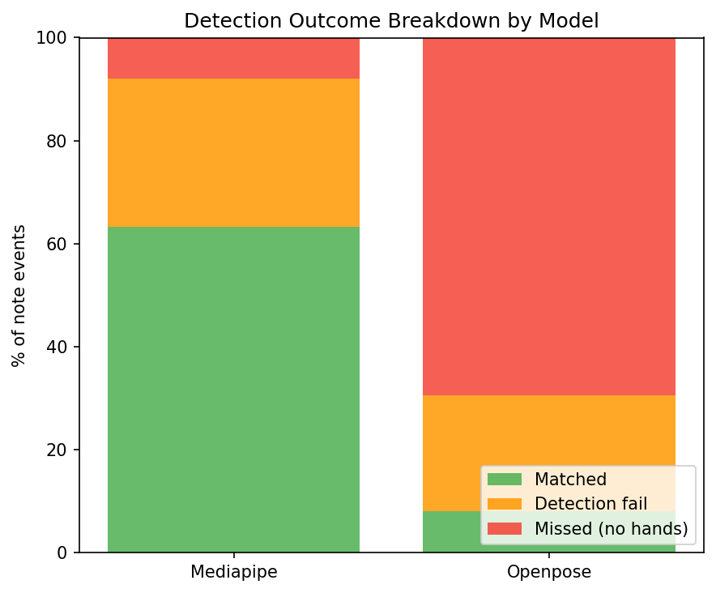
Fig 8.1.1.a: MediaPipe vs OpenPose detection rate comparison chart
FINDING MediaPipe detected landmarks in 91.8% of events (matched + detection_fail). OpenPose only detected landmarks in 29.7% of events, because it requires a tightly cropped hand image as input — the full-scene video feed used here is not its intended use case.

6.2 Per-Hand and Per-Finger Detection Rate
MediaPipe showed consistent per-finger detection across both hands with the thumb achieving the highest match rate. OpenPose detection was too sparse to produce reliable per-finger statistics.

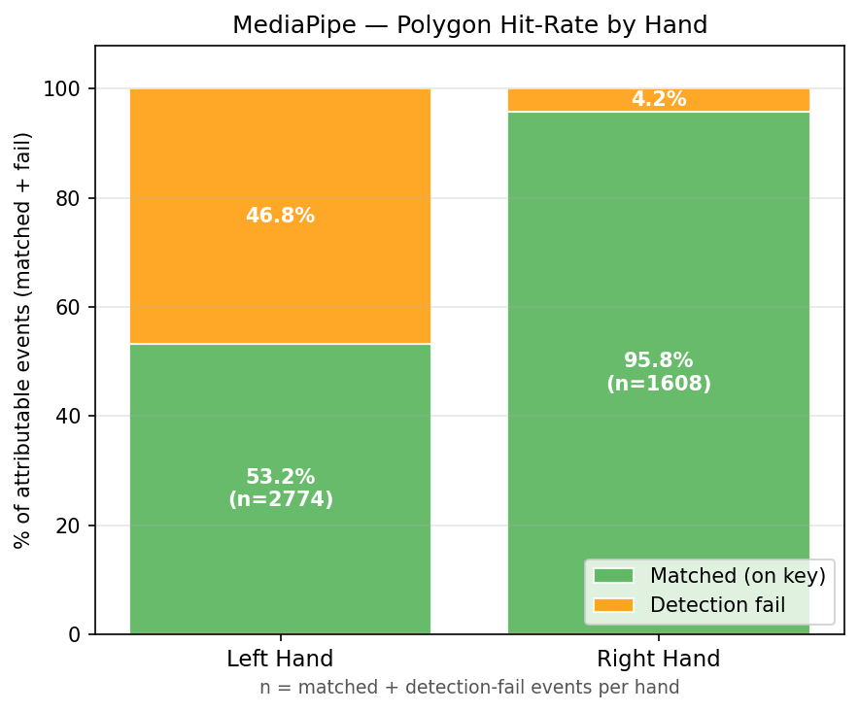
Fig 8.1.3.a: Per-hand and per-finger detection rate for MediaPipe
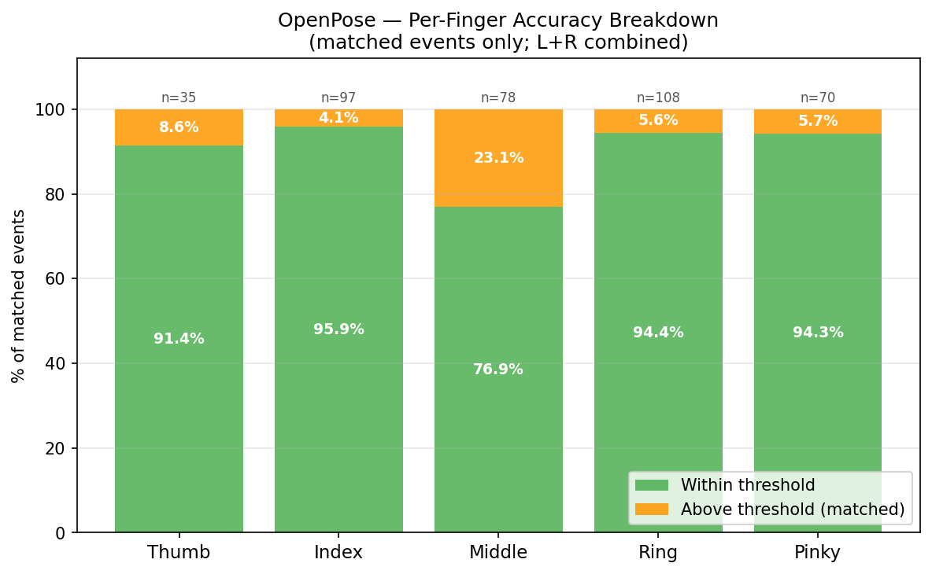
Fig 8.1.3.c: Per-finger detection rate for OpenPose (low n — limited reliability)

6.3 Detection-Fail Rate by Skin Tone
Detection-Fail Rate (DFR) measures cases where landmarks were detected but no tip landed inside the key polygon — indicating positioning error rather than complete model failure.
Fitzpatrick Type | MediaPipe DFR % | OpenPose DFR %
Type II | 16.8 | 44.1
Type III | 32.8 | 15.5
Type IV | 26.4 | 25.2
Type V | 30.5 | 31.2

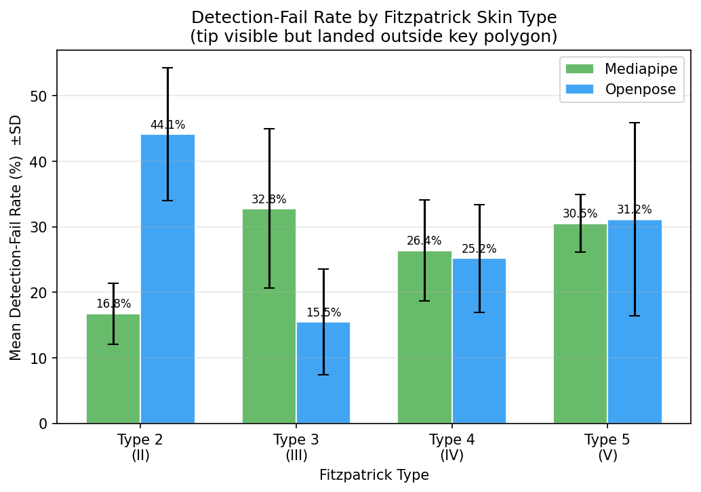
Fig 8.1.4.a: Detection-fail rate by Fitzpatrick skin tone type
FINDING No consistent upward or downward trend with skin tone is visible for MediaPipe. The lowest DFR (16.8%) occurs at Type II, and the highest (32.8%) at Type III — suggesting no systematic skin-tone bias.

6.4 Detection-Fail Rate by Lighting Condition
Lighting | MediaPipe DFR % | OpenPose DFR %
Dim (<100 lux) | 28.6 | 21.7
Indoor (100-499 lux) | 28.7 | 29.9
Bright (>=500 lux) | — | —

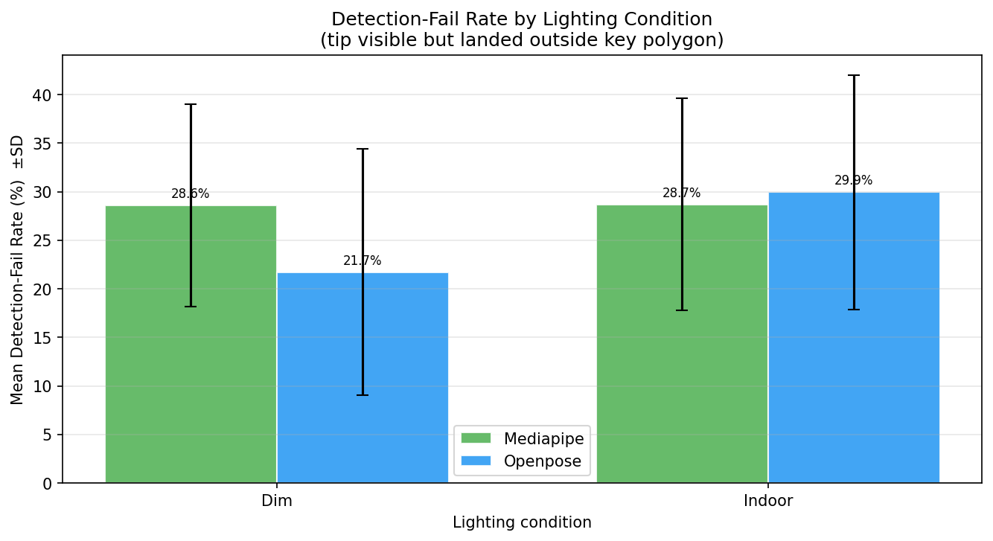
Fig 8.1.5.a: Detection-fail rate by lighting condition
FINDING MediaPipe showed effectively zero difference between Dim and Indoor conditions (28.6% vs 28.7%). Bright conditions were not represented in the dataset — all sessions were conducted indoors.

7. MPJPE Results

7.1 Overall Model Comparison
MPJPE is only computed over matched events (fingertip inside polygon). OpenPose's lower MPJPE (5.87 px vs 6.07 px) is calculated on only 8.1% of total events, making direct comparison misleading — MediaPipe's result covers 63.3% of all events.
Metric | MediaPipe | OpenPose
Mean MPJPE (px) | 6.07 | 5.87
Median MPJPE (px) | 5.1 | 4.9
Detection rate (%) | 63.3 | 8.1
Events matched (n) | 3,017 | 388

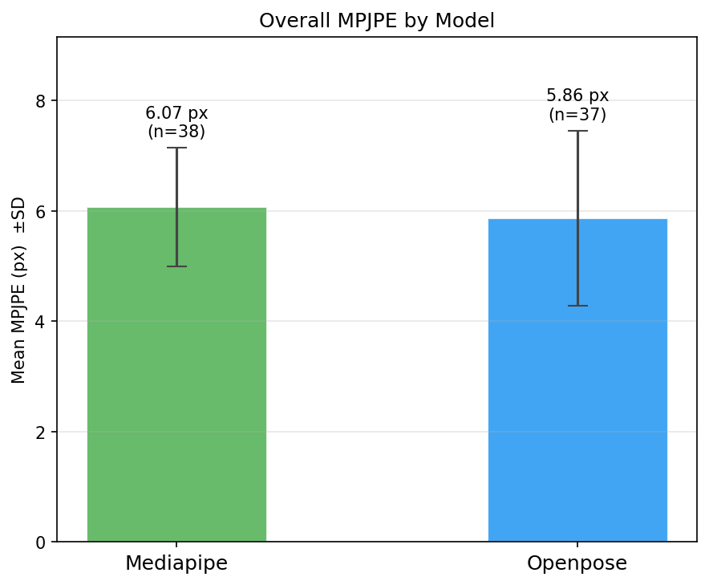
Fig 8.2.1.a: Overall MPJPE comparison — MediaPipe vs OpenPose

7.2 2D Mask Perspective Limitation
When the camera is angled overhead, black keys further from the camera appear narrower and offset relative to their physical position. The 2D polygon mask cannot fully compensate for this 3D key geometry. Both models were tested against the same mask, so the bias is consistent and the comparative result remains valid.

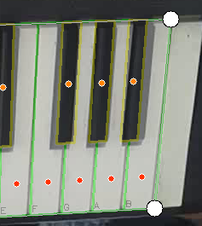
Fig 8.2.2.a: Black key 2D calibration mask misalignment due to camera perspective

7.3 MediaPipe Per-Finger MPJPE
Hand | Thumb | Index | Middle | Ring | Pinky
Left (MPJPE px) | 5.7 | 5.8 | 6.5 | 6.6 | 5.5
Right (MPJPE px) | 5.7 | 5.8 | 6.4 | 6.6 | 5.3

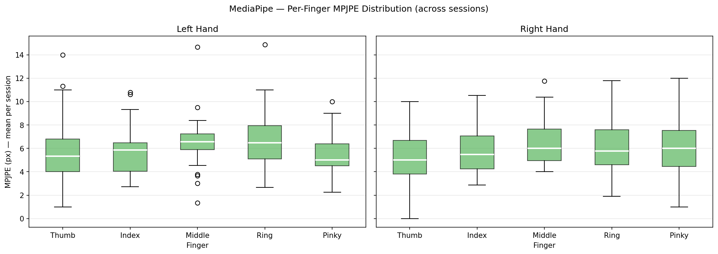
Fig 8.2.3.b: Per-finger MPJPE breakdown for MediaPipe — Left and Right hands

Fig 8.2.3.d: MediaPipe per-hand polygon hit rate
FINDING Ring and Middle fingers consistently show the highest MPJPE across both hands (6.5-6.6 px), consistent with their anatomical tendency to move in coordination rather than independently.

7.4 OpenPose Per-Finger MPJPE
Finger | Thumb | Index | Middle | Ring | Pinky
MPJPE (px) | 6.9 | 5.8 | 6.1 | 6.1 | 4.4

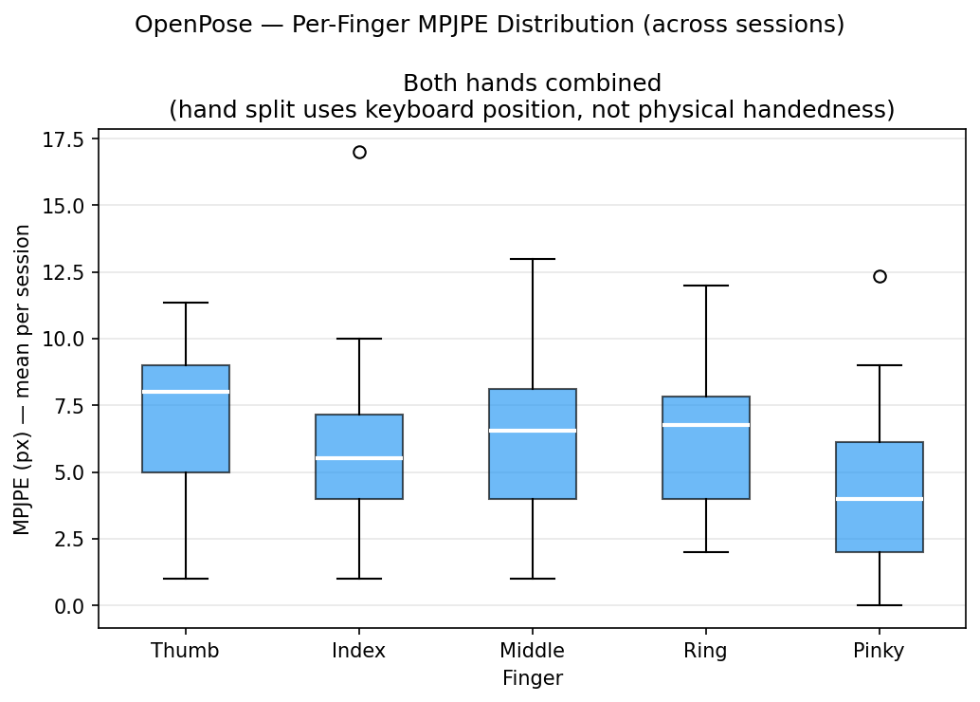
Fig 8.2.4.b: OpenPose per-finger MPJPE — both hands combined
FINDING OpenPose shows the inverse pattern to MediaPipe: highest MPJPE at the Thumb (6.9 px), lowest at Pinky (4.4 px). This may reflect the different cropping strategy used for OpenPose inference.

8. Effect of Skin Tone on MPJPE
Fitzpatrick Type | MediaPipe MPJPE (px) | OpenPose MPJPE (px)
Type II | 5.51 | 6.41
Type III | 6.02 | 5.70
Type IV | 6.39 | 5.53
Type V | 5.96 | 6.34

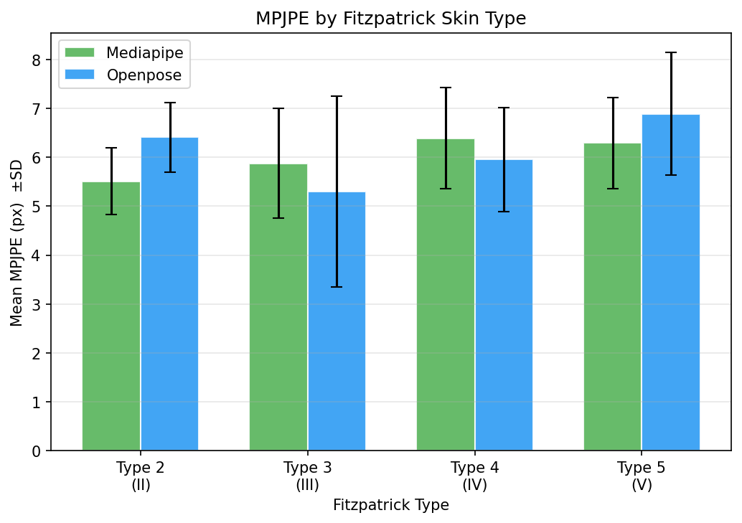
Fig 8.3.2.b: Mean MPJPE per Fitzpatrick type — MediaPipe and OpenPose
FINDING MediaPipe shows a mild upward trend from Type II (5.51 px) to Type IV (6.39 px), but the difference is small. Types I and VI were not represented in the dataset. OpenPose shows no consistent trend.

9. Effect of Lighting on MPJPE
Condition | MediaPipe (px) | OpenPose (px)
Dim (<100 lux) | 6.03 (SD=1.16, n=28) | 6.17
Indoor (100-499 lux) | 6.08 (SD=1.01, n=10) | 5.04

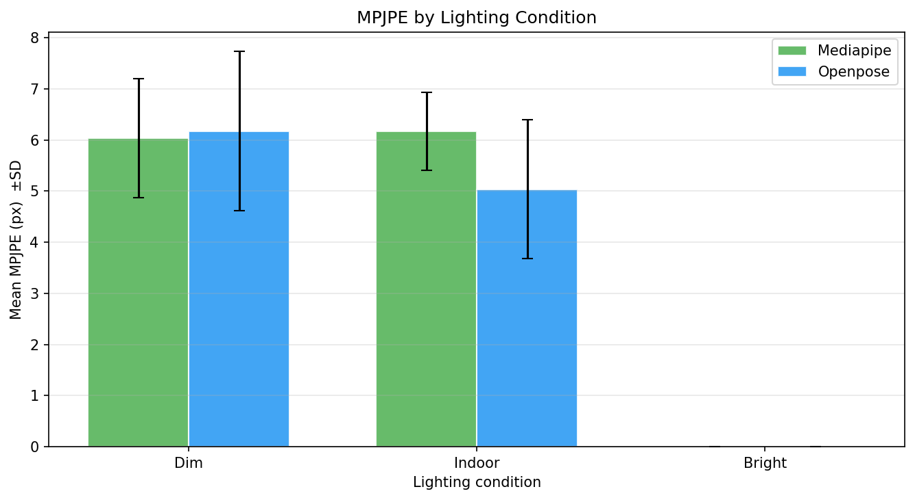
Fig 8.4.2.b: Mean MPJPE per lighting category — MediaPipe and OpenPose
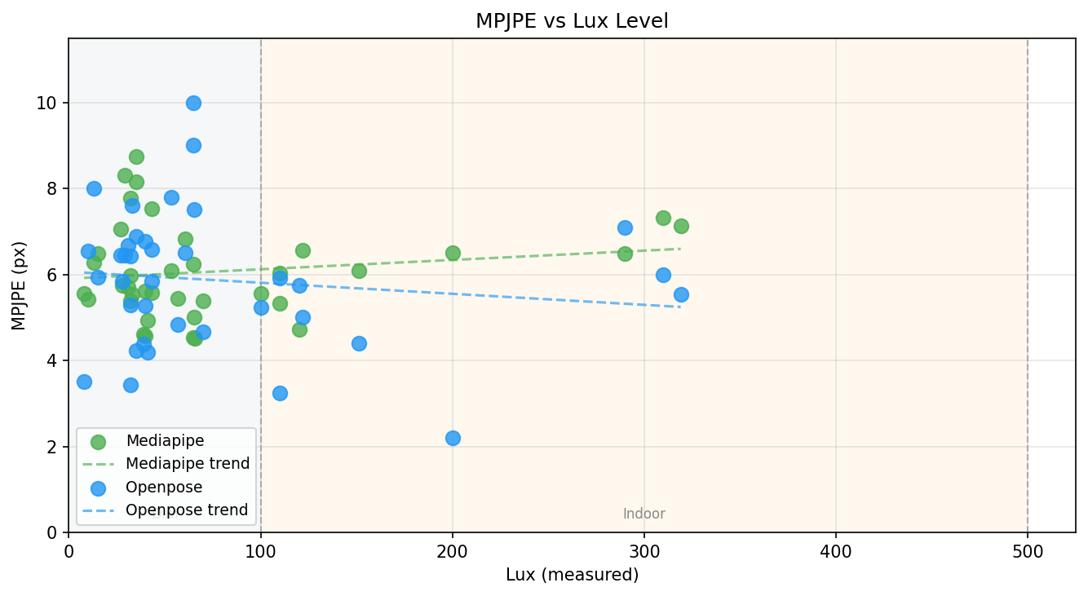
Fig 8.4.2.c: MPJPE vs lux level scatter plot
FINDING MediaPipe showed no meaningful difference between Dim and Indoor conditions (6.03 vs 6.08 px). OpenPose showed more variation (6.17 vs 5.04 px) but with a small indoor sample (n=10). Bright conditions (>=500 lux) were not represented.

10. Effect of Hand Size on MPJPE
Metric | MediaPipe | OpenPose
Regression slope (px/cm) | 0.162 | 0.336
R-squared | 0.030 | 0.059
Hand size range (cm) | 7.7-12.2 | 7.7-12.2

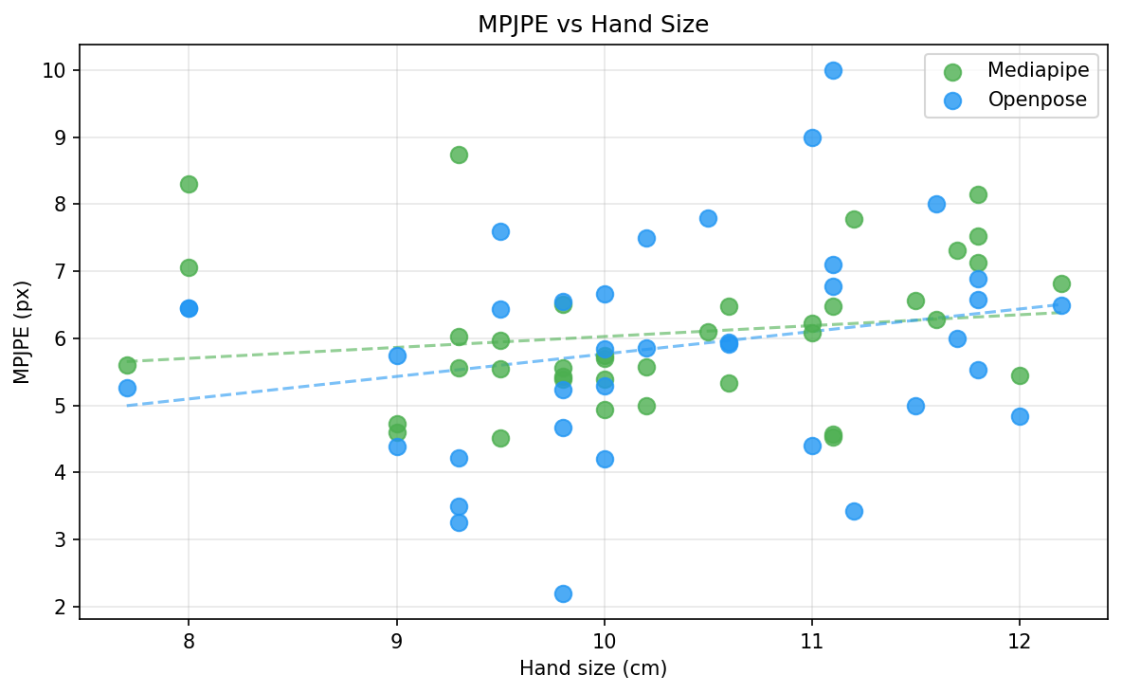
Fig 8.5.2.a: MPJPE vs hand size scatter plot with regression lines
FINDING Both regression R-squared values are below 0.06, indicating that hand size explains less than 6% of MPJPE variance. MediaPipe performs consistently across the full adult hand size range tested without per-user recalibration.

11. Summary of Evaluation Findings
Finding | MediaPipe | OpenPose
Detection rate | 63.3% | 8.1%
Mean MPJPE (px) | 6.07 | 5.87 (on 8.1% of events)
Skin tone effect | Mild upward trend — not significant | No consistent trend
Lighting effect | Negligible (Dim vs Indoor) | Larger variation but small n
Hand size effect | R2=0.03 — negligible | R2=0.06 — negligible
Practical recommendation | Best for full-scene deployment | Requires pre-cropped hand input

RESULT MediaPipe is the recommended model for full-scene piano tracking. It achieves a mean MPJPE of 6.07 px (well below the ~10 px threshold for a standard white key) with a detection rate of 63.3%. OpenPose's marginally lower MPJPE (5.87 px) is not comparable — it only detected landmarks on 8.1% of events using the full-scene input.

